Baseline Topology test

Show Running Configurations
Router0
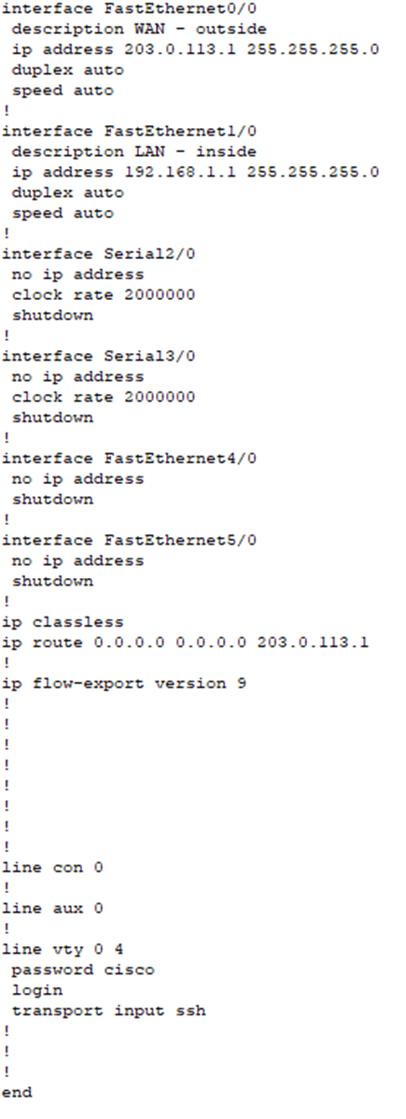
- Router password set default password Cisco
- Configure Password to something more secure
- no service password-encryption
Switch0
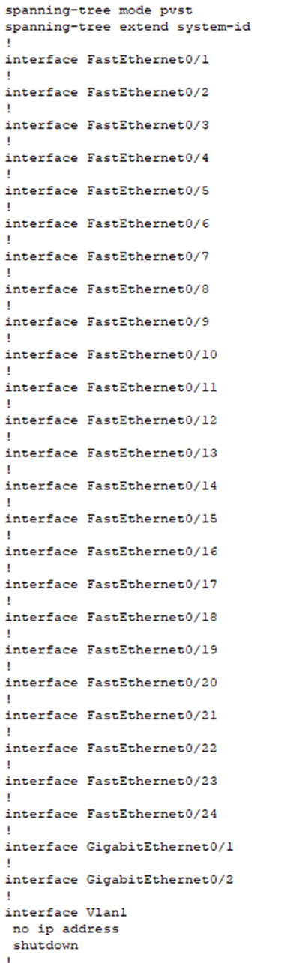
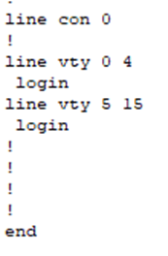
• No password
• Configure Password
- No Vlans

Test 1 Internal Network
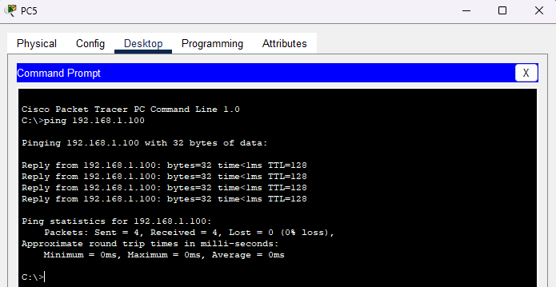
Ping from PC5 (user) to dhcp server (192.168.1.100) Status: Success
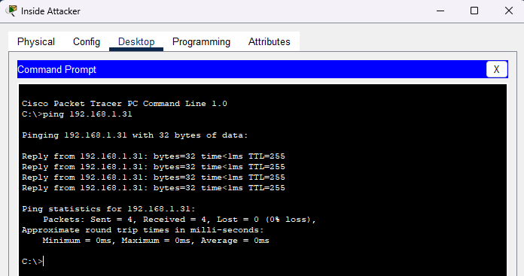
Ping Inside attacker to IoT 3 (192.168.1.31) Status: Success
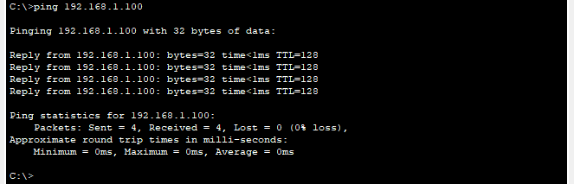
Ping From Inside attacker(user) to dhcp server (192.168.1.100) Status: Success
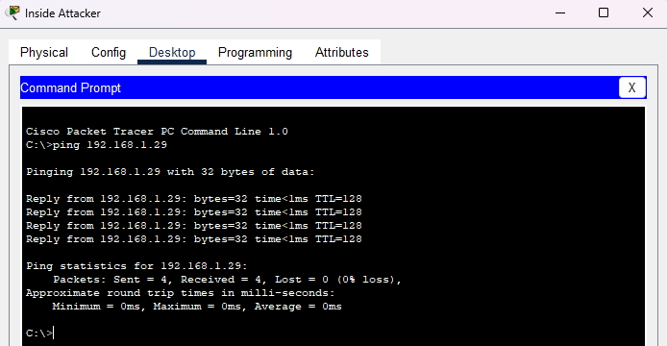
ping from inside attacker (user) to pc2 (192.168.1.29) Status: success

Test 2 Outside attacker
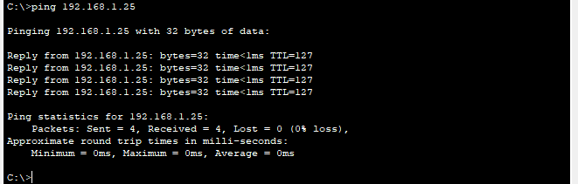
Ping From outside attacker to PC5(user) Status: success

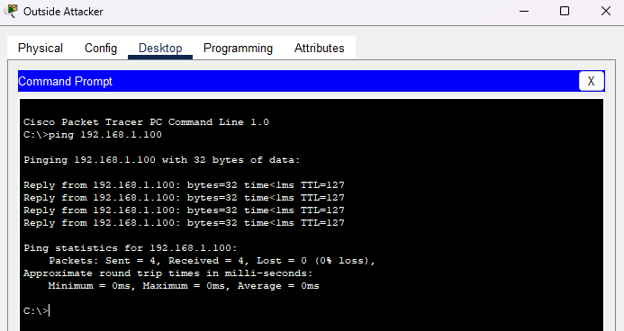
Ping From outside attacker to dhcp server (192.168.1.100) Status: success

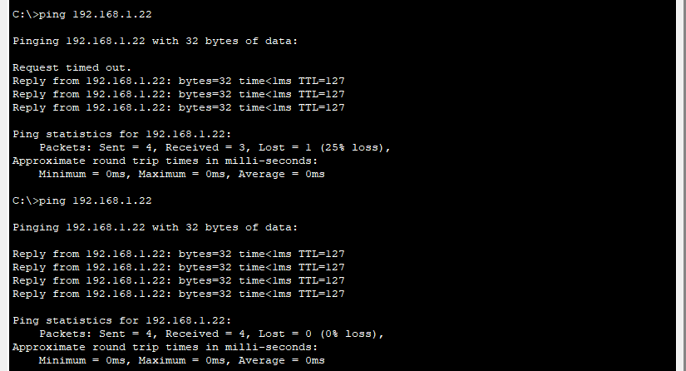
Ping From outside attacker to PC4 (management) Status: success

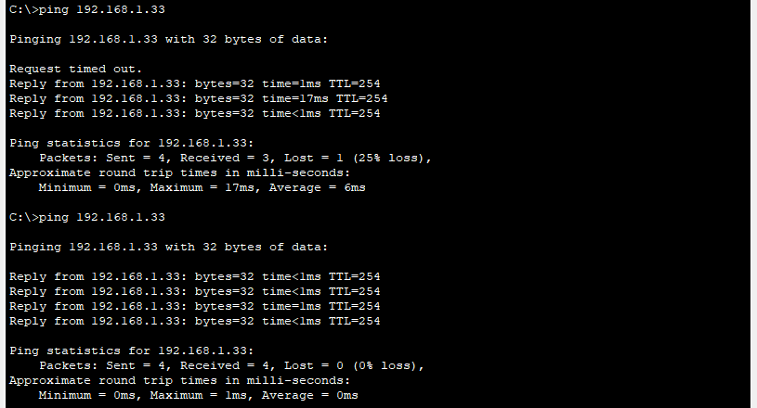
Ping Outside attacker to IoT 3 (192.168.1.31) Status: Success

- Outside attacker ping every device in the network

DoS Attacks

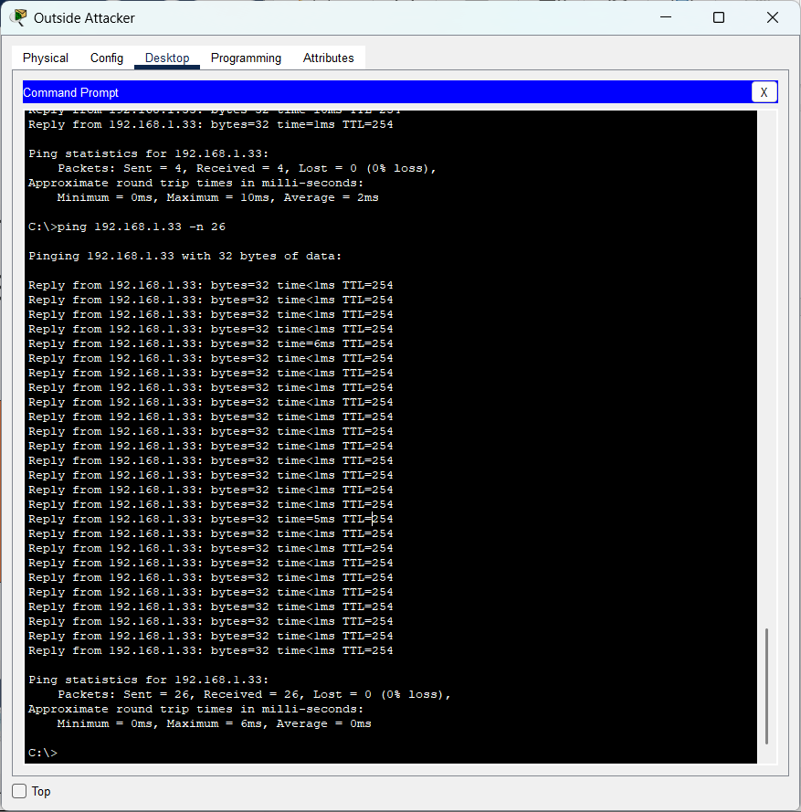
Ping from outside to IoT (ping 192.168.1.33 -n 26)
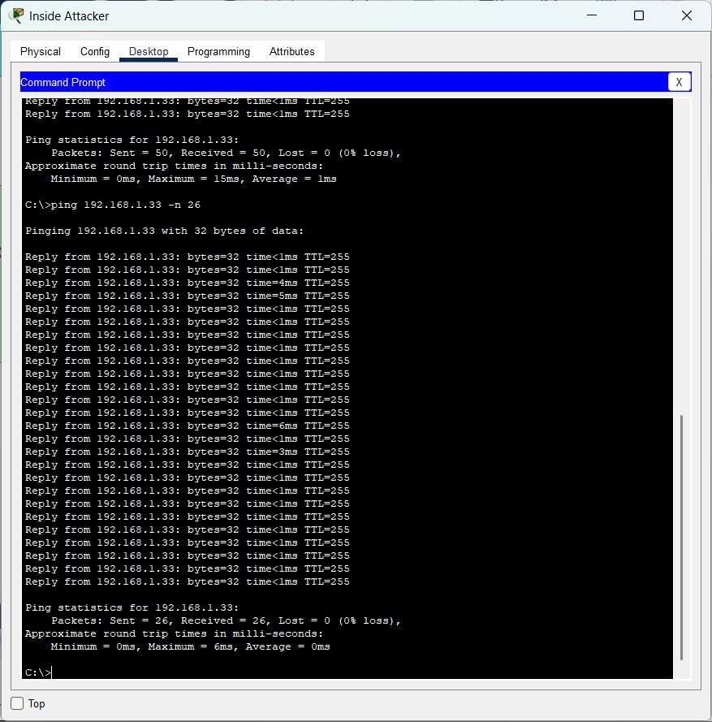
Ping from inside attacker(ping 192.168.1.33 -n 26)

